**2.Can you share the Wi-Fi devices that you are using day to day life, share that device's wireless capability/properties after connecting to network. Match your device to corresponding Wi-Fi Generations based on properties.**

**Common Wi-Fi devices:**

* Laptops
* Smartphones
* Tablets
* Smart TVs
* Routers

**WiFi Capability:**

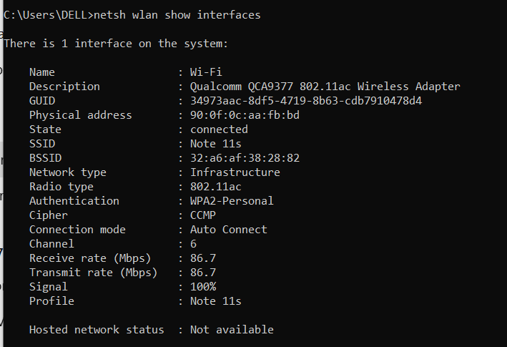

**WiFi Generation:**

802.11ac - Wi-Fi 5